|  |  |  |  |  |  |  |  |  |  |  |  |  |  |  |  |  |  |  |  |  |  |  |
| --- | --- | --- | --- | --- | --- | --- | --- | --- | --- | --- | --- | --- | --- | --- | --- | --- | --- | --- | --- | --- | --- | --- |
| **INTERSTATE CONTAINER CORPORATION** | | | ***Date:* 08/11/2015** | ***Spec #:*** | | | | | | | | | | ***Design #:*** | | **150407-01** | | | |  |  |  |
|  |  |
| ***Customer:* DeMet's Candy** |  |  |  |  |  |  |  |  |  |  |  |  |  |  |  |  |  |  |  |  |  |  |
|  |  |  |  |  |  |  |  |  |  |  |  |  |  | ***Cut*** |  |  |  | **154 in.** | |  |  |
|  |  |  |  |  |  |  |  |  |  |  |  |  |  |  |  |  |  |  |
| ***Description:* Small Hearts/Acetate Tray/12 ct - RSC.601/1** | | |  |  |  |  |  |  |  |  |  |  |  |  |  |  |  |  |  |
|  |  |  |  |  |  |  |  |  |  |  |  | ***Crease*** |  |  |  | **118 in.** | |  |  |
|  |  |  |  |  |  |  |  |  |  |  |  |  |  |  |  |  |
| ***Style:* RSC** | ***Revision Info:* [0] 04/29/2015:** | |  |  |  |  |  |  |  |  |  |  |  |  |  |  |  |  |  |
|  |  |  |  |  |  |  |  |  |  |  |  |  |  |  |  |  |  |  |  |
|  |  |  |  |  |  |  |  |  |  |  |  |  |  |  |  |  |  |  |  |
| ***I.D. :* 8+1/2 x 7+3/16 x 14+1/16** | ***Blank size:* 21+5/8 x 33+1/8** | |  |  |  |  |  |  |  |  |  |  |  |  |  |  |  |  |  |  |  |  |
|  |  |  |  |  |  |  |  |  |  |  |  |  |  |  |  |  |  |  |  |
| ***Board:* 32 B K** | ***Combination:* 35HP - 23M - 35HP** | | ***Designer:* Brian Romankow** | | |  |  |  |  |  |  |  |  |  |  |  |  |  |  |  |  |  |
|  |  |  |  |  |  |  |  |  |  |  |  |  |  |  |  |  |
| FL924 |  |  | **LEAD EDGE** |  |  |  |  |  |  |  |  |  |  |  |  |  |  |  |  |  |  |  |
|  |  |  |  |  |  |  |  |  |  |  |  |  |  |  |  |  |  |  |  |  |
|  |  |  |  |  |  |  |  |  |  |  |  |  |  |  |  |  |  |  |  |  |  |
|  |  |  |  |  |  |  |  |  |  |  |  |  |  |  |  |  |  |  |  |  |  |  |
|  |  |  |  |  |  |  |  |  |  |  |  |  |  |  |  |  |  |  |  |  |  |  |

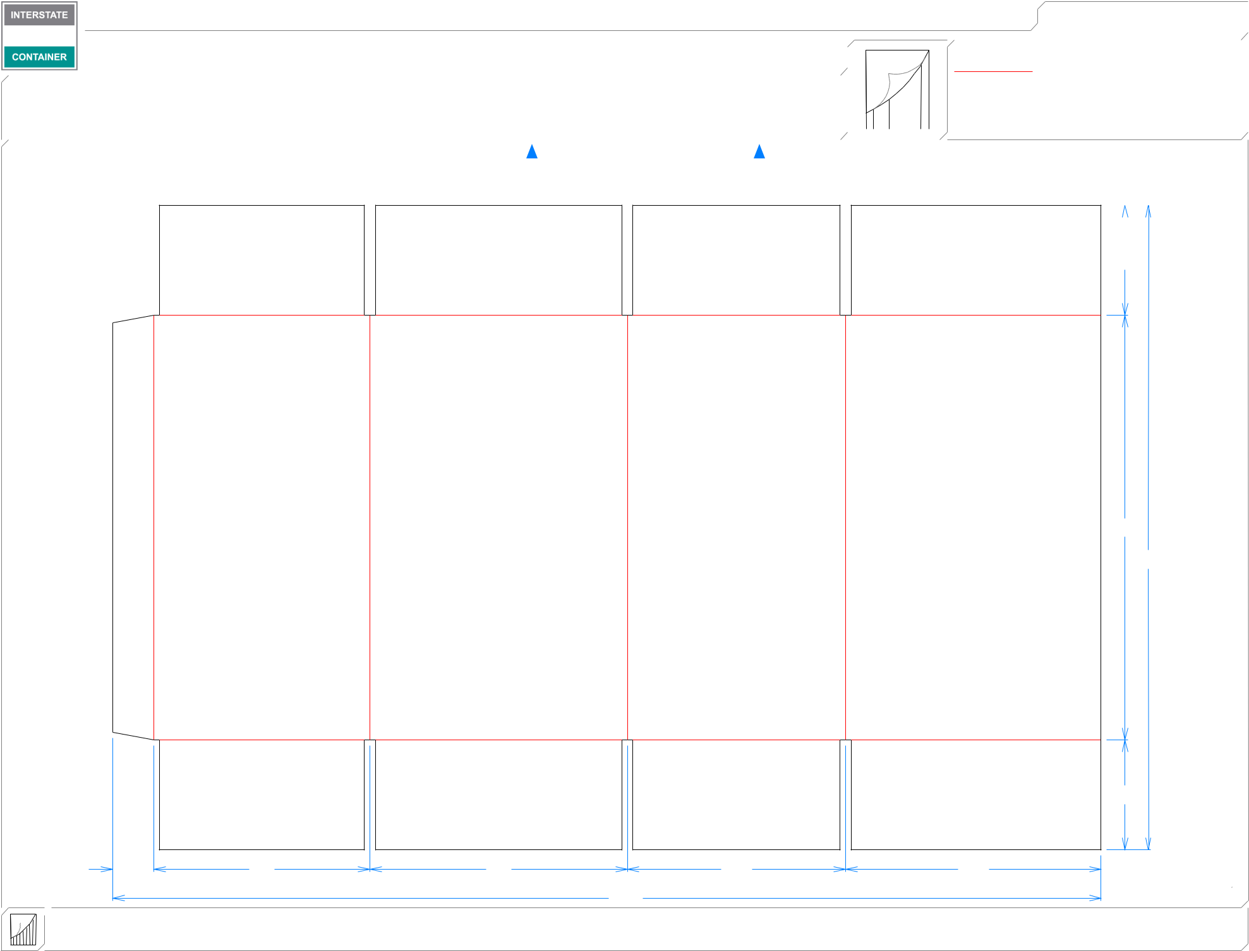

|  |  |  |  |  |
| --- | --- | --- | --- | --- |
| 13*/*8 | 71*/*4 | 85*/*8 | 75*/*16 | 89*/*16 |
|  |  |  | 331*/*8 |  |

311*/*16

141*/*4

215*/*8

311*/*16

**inside view**

**Vertical Corrugation**

***notes:***

***Qty/unit:*** ***Area - waste:* 4.83 sq. ft** ***Waste on blank:* 2.8%** ***Piece weight - waste:* 0.5 lbs./226.13 g**